The Science of Computing III Living with Cyber

Workbook: More on Objects Pillar: Computer Programming

1. Fill out the following table.
 | Definition | Purpose and/or how it is dealt with
Abstraction
Modularization
Method lookup
Single inheritance
Multiple inheritance
Abstract method
Abstract class
Concrete class
Unit
Coupling
Cohesion

2. Create the code to represent the following class diagram. Note that the pass keyword is an acceptable way to stub out a function for later implementation in Python.

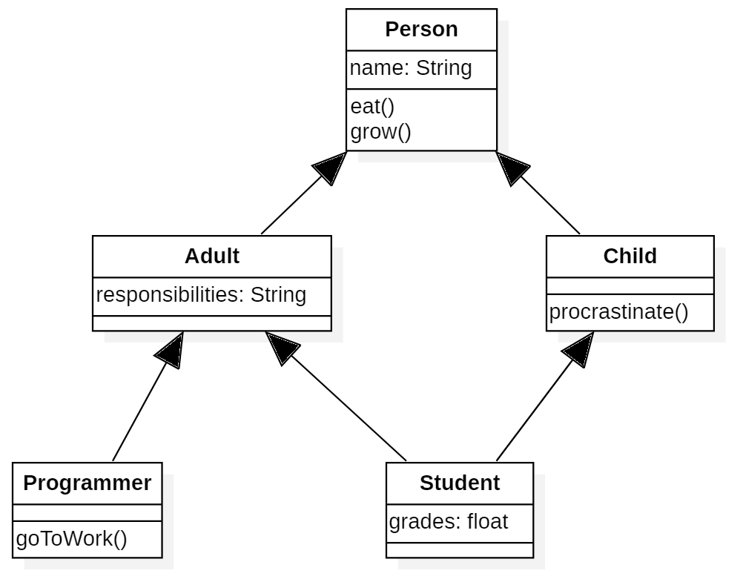

3. Use the following class stubs to draw a representative class diagram that shows classes, members, and relationships. Note that the pass keyword is an acceptable way to stub out a function for later implementation in Python.

class OperatingSystem(object):
def __init__(self, version):
self.version = version

def run(self):
pass

class Linux(OperatingSystem):
def __init__(self):
pass

def openTerminal(self):
pass

class Mac(OperatingSystem):
def __init__(self):
pass

def openFinder(self):
pass

class Windows(OperatingSystem):
def __init__(self):
pass

def openExplorer(self):
pass

4. What is the output of the following program?
import abc

class Animal(object):
__metaclass__ = abc.ABCMeta

def __init__(self):
""" constructs a new Animal """

def __str__(self):
return "Animal"

class Mammal(Animal):
__metaclass__ = abc.ABCMeta

def __init__(self):
Animal.__init__(self)

def __str__(self):
return "mammal"

class Ape(Mammal):
def __init__(self, owner = "Cincinnati zoo"):
Mammal.__init__(self)
self.owner = owner

def __str__(self):
return "{}".format(self.owner) + ", Ape, " + Mammal.__str__(self)

class Wolf(Mammal):
def __init__(self):
Mammal.__init__(self)

def __str__(self):
return "wolf"

class Snail(Animal):
def __init__(self):
Animal.__init__(self)

a1 = Ape()
a2 = Ape("Kong")
w1 = Wolf()
s1 = Snail()
print(a1)
print(a2)
print(w1)
print(s1)

